**Without Isolation**

**My Permits –** This includes permits that you own and are responsible for.

**Dept Permits –** Permits owned by the department, but still under your purview.

**Open Permits –** Permits that are in progress, meaning they haven’t been completed yet.

**Closed Permits –** Permits that have been completed and are now closed.

**Step 1**

Requestor must fill out all the mandatory fields before submitting the permit request. If any required field is left blank, the system will display an error message, alerting the requestor to complete all mandatory inputs.

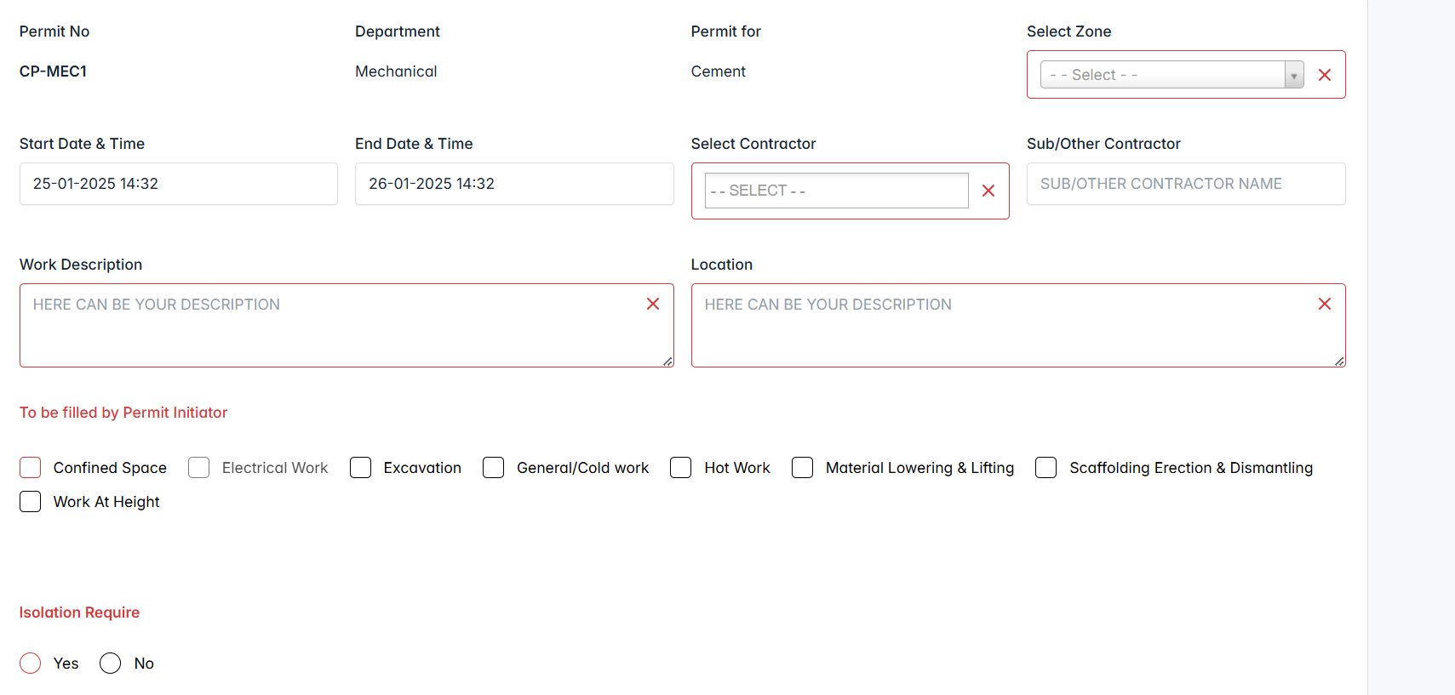

Initiated the new permit successfully. It’s started to listing under “My Permits”. Status is changed to “**Waiting Custodian/HOD Approval**”. Initiator can edit the permit info until the Custodian/HOD approve the permit.

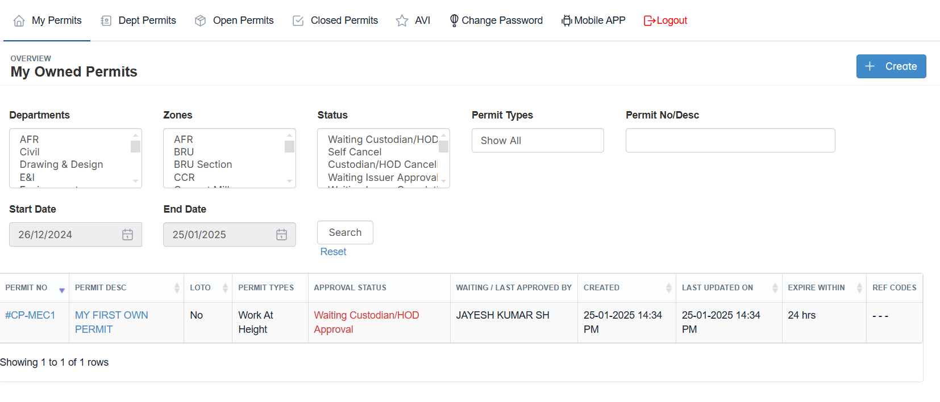

If, initiator won’t like to continue the permit, they can cancel the permit before getting approval from “Custodian/HOD”

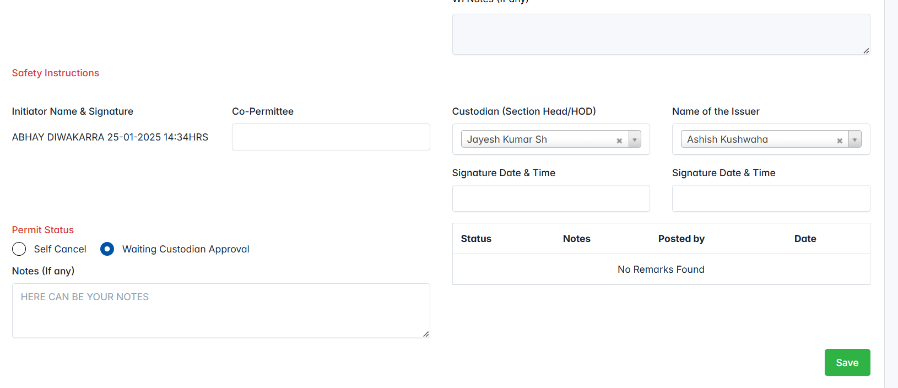

**Step 2 Responsible Person : Custodian/HOD**

Logged as Custodian/HOD and reviewing the permit. Now, Custodian approved the permit. Status is changed to “**Waiting Issuer Approval**”.

**Reopen –** This seems to mean that the permit is being sent back to the initiator for further action or clarification.

**Cancel** – The custodian is withdrawing or canceling the permit for some reason, possibly due to changes or issues with the request.  
  
**Approve** – The permit is moving forward to the issuer for final approval.

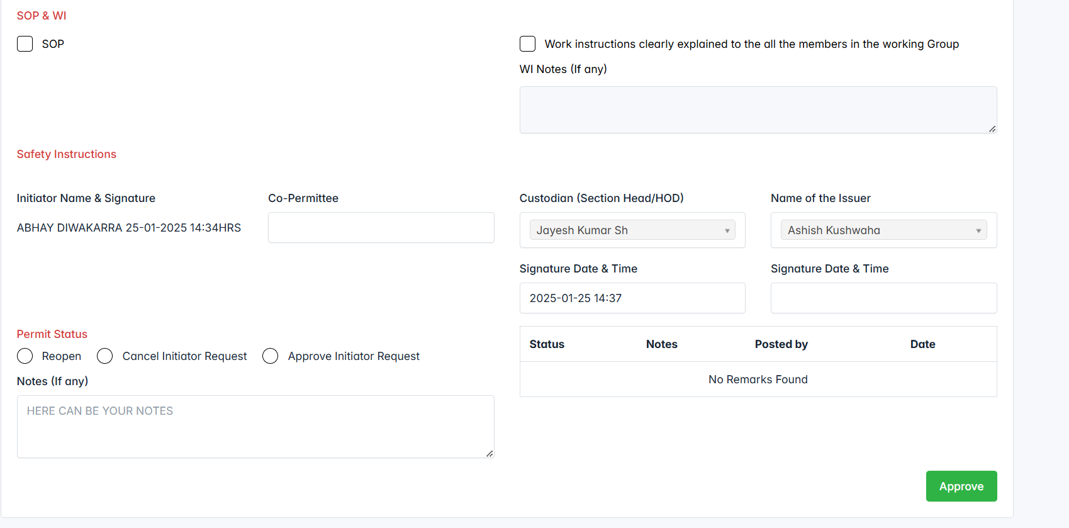

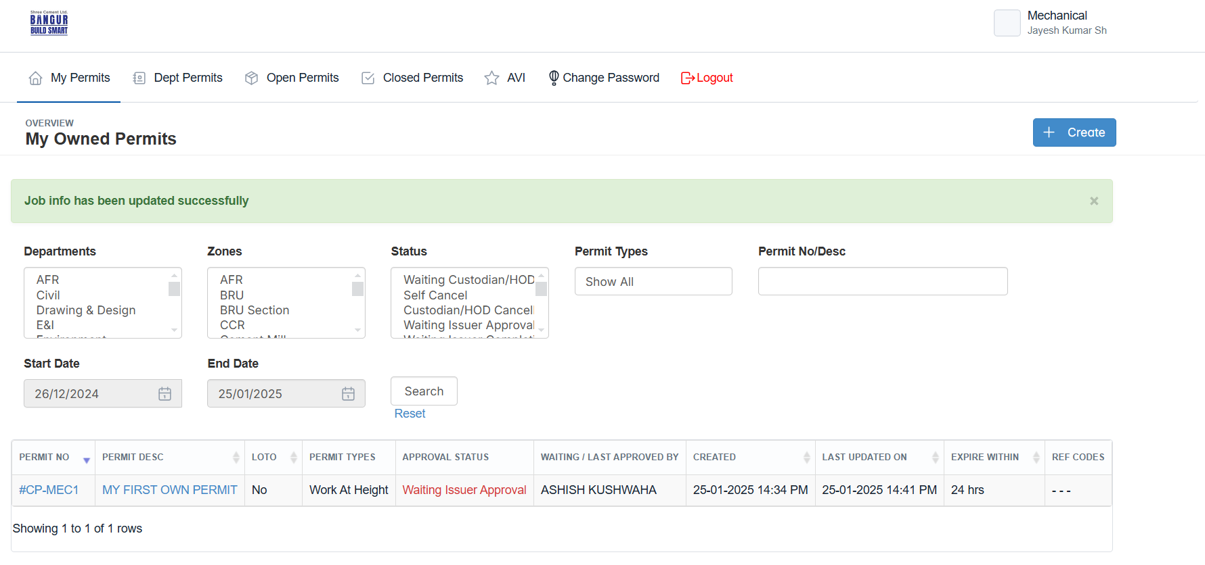

**Step 3 Responsible Person : Issuer**

Logged as “Issuer” and started the permit info.

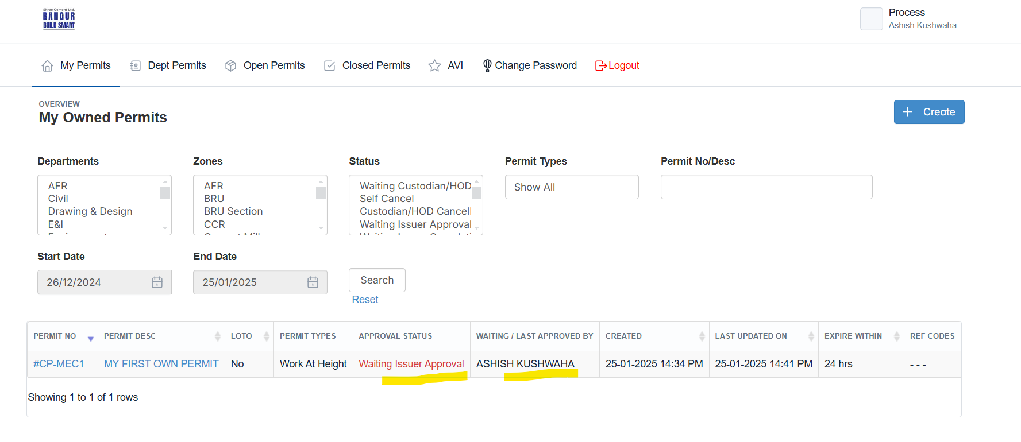

Issuer has the ability to either approve, cancel, or reopen a permit. When the permit is approved, it moves forward to the next step(**Final Submit**) in the process, and if not approved, it is sent back for revisions or further review.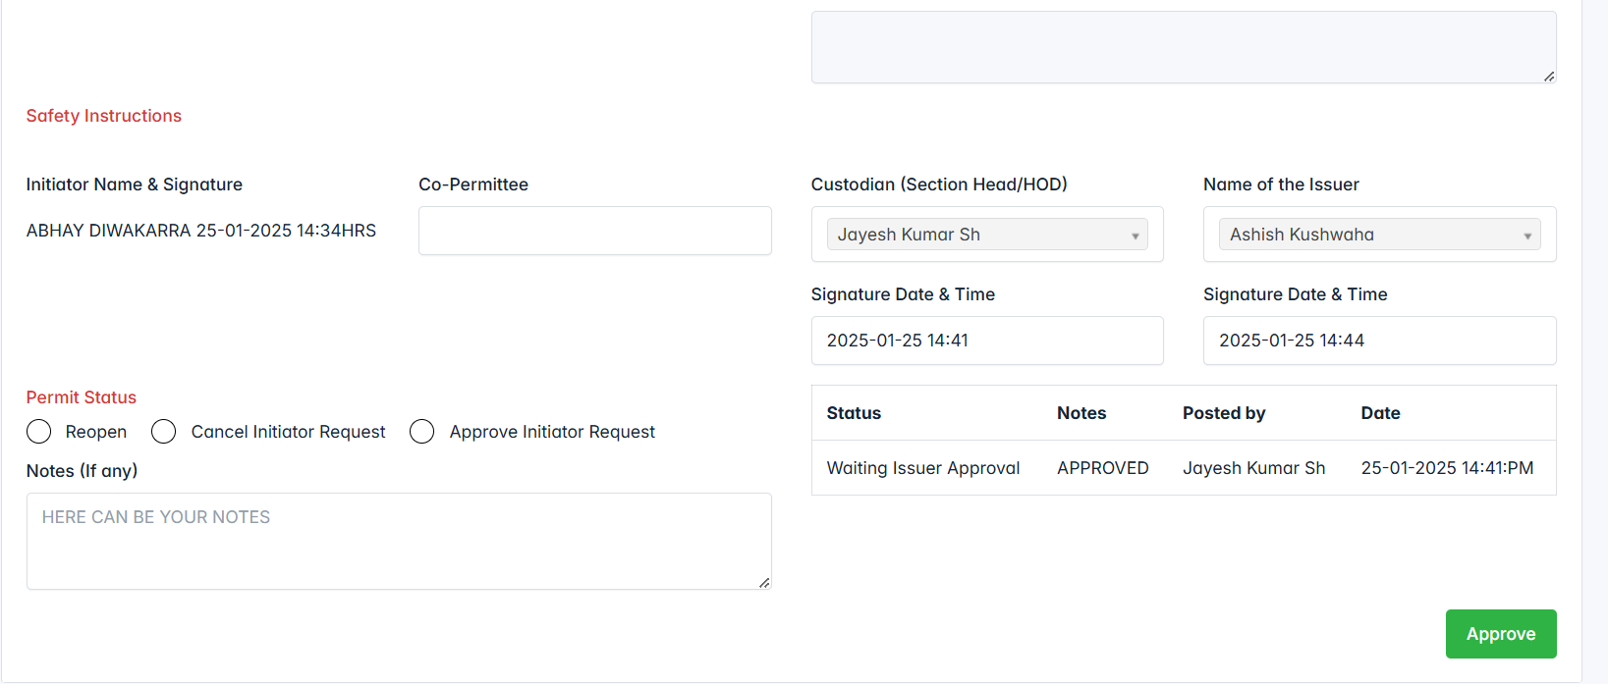

**After approved by Issuer.**

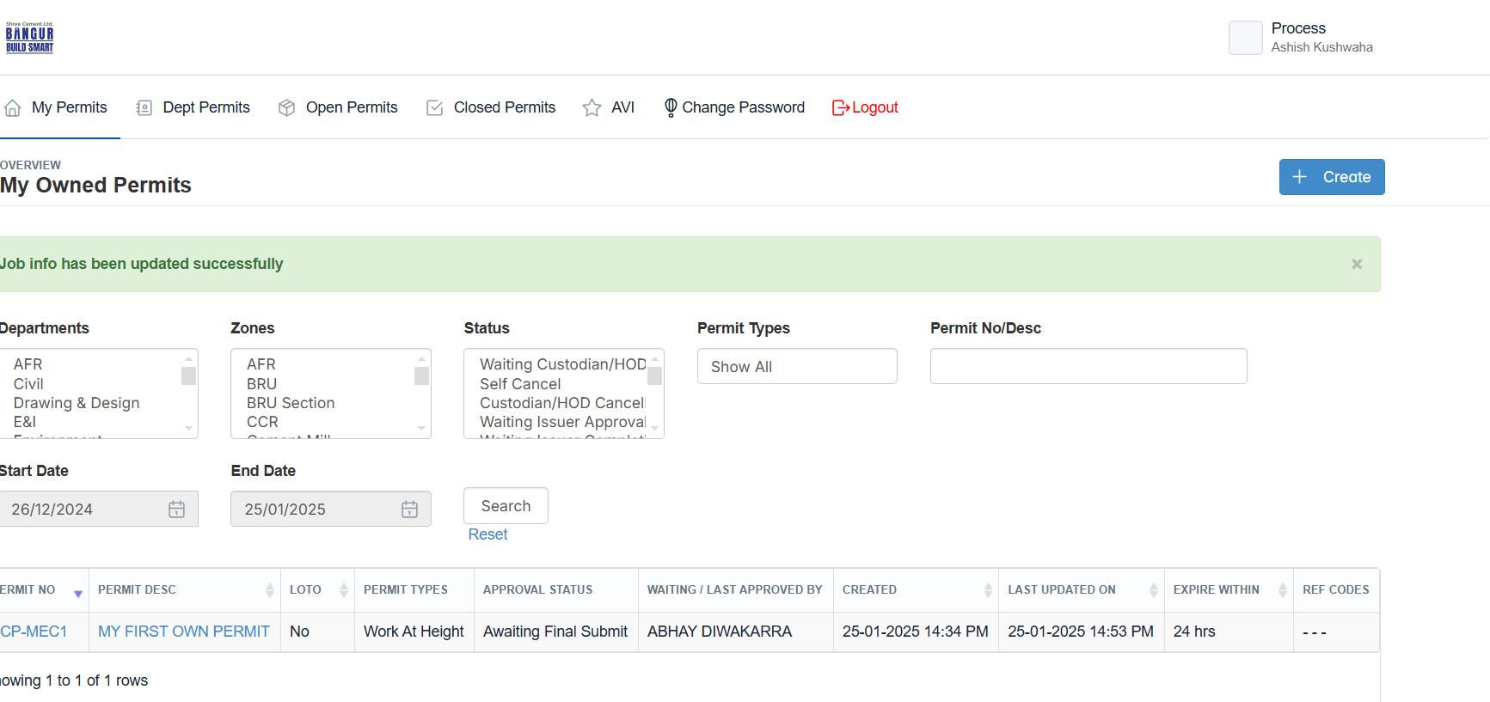

**Step4 Responsible Person : Initiator**

Once, the permit reach “Final Submit”, requestor can be the confirm that and start their works.

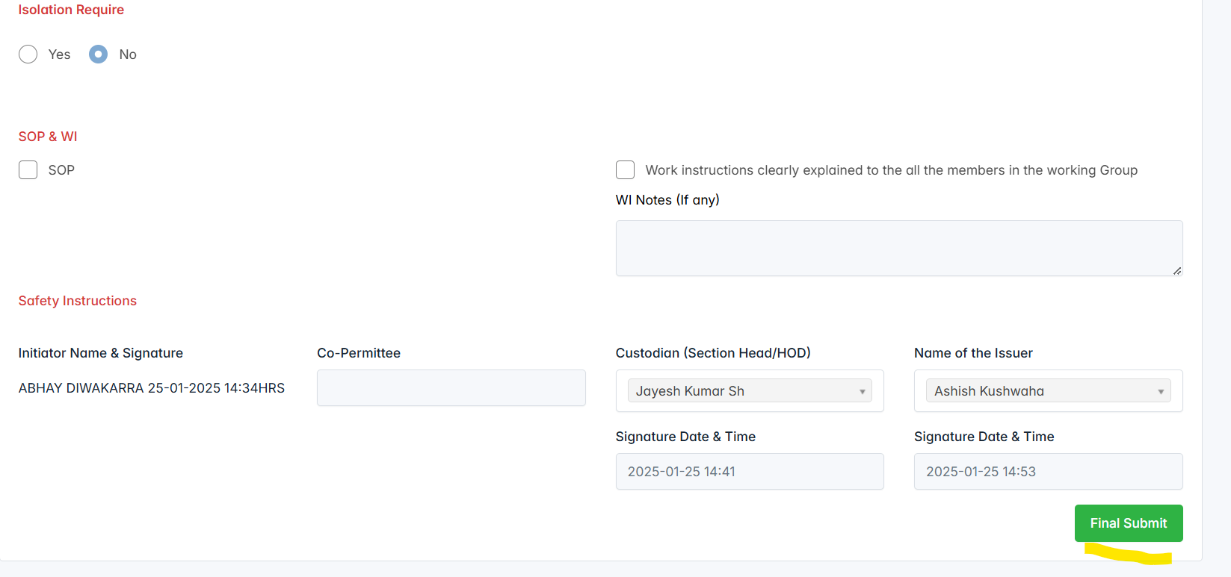

**Logged as “Requester” and done the Final Submit. Now, the permit status is changed “In Progress”.**

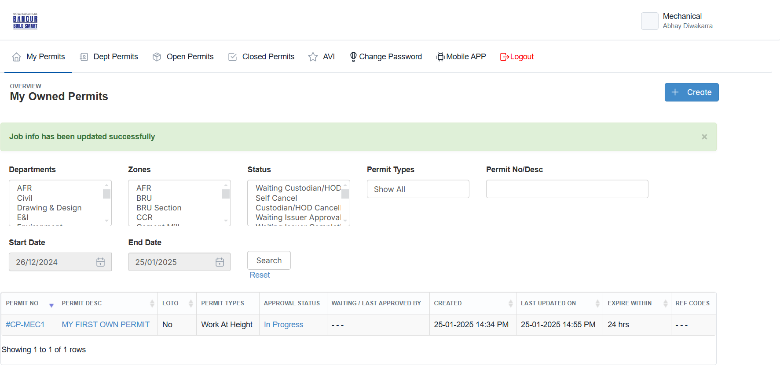

**Step5 Responsible Person : Initiator**

**From the "In Progress" stage, there are three options to move the permit forward.  
  
Completion –** This likely signifies that the permit is finished and can be finalized.

**Cancellation –** This option would stop the permit process entirely.

**Extension –** This allows for more time to work on the permit before moving forward.

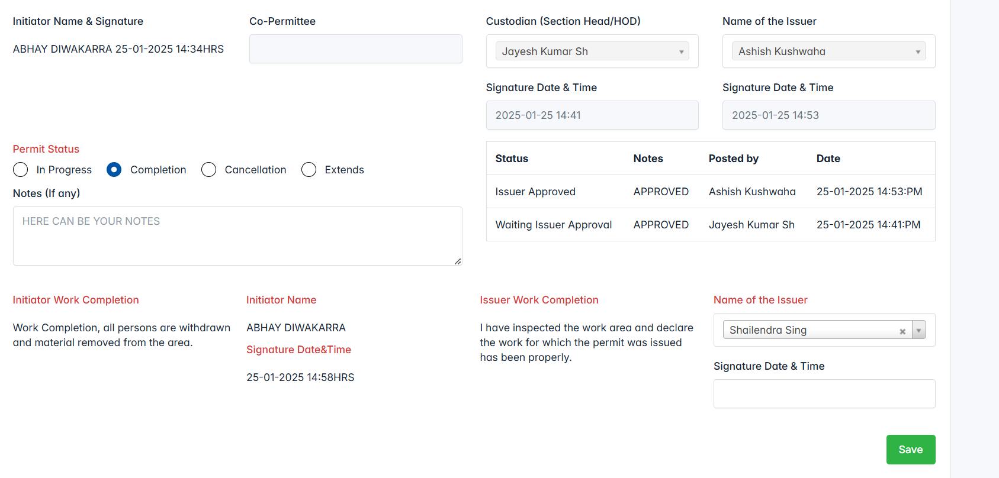

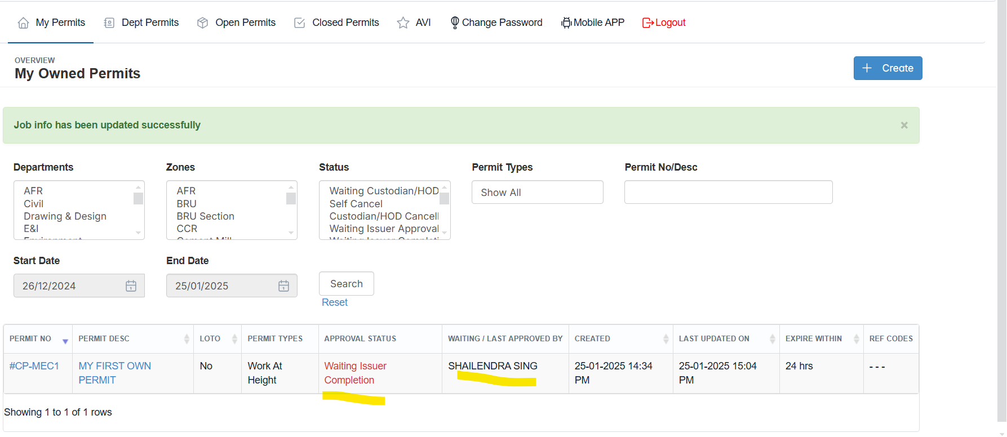

**Step7 Responsible Person : Issuer**

Logged as issuer to approve the Cancellation/Completion the permits requested by the requestors.

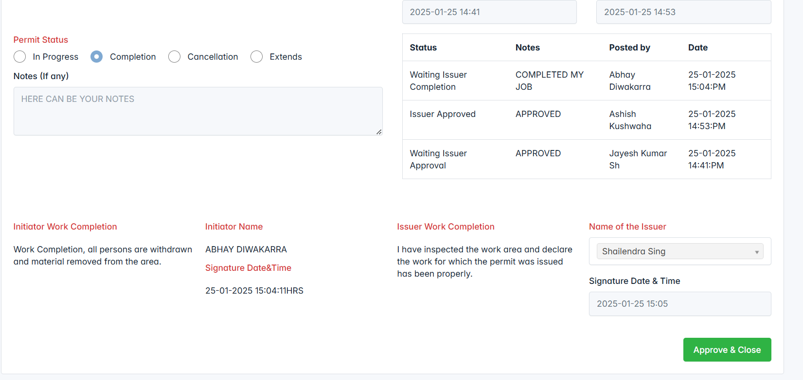

**That’s it. Now, the permit is completed and moved to “Closed Permit”.**

